ORDINANCE #2026-09
ORDINANCE MODIFYING LOCAL INCOME TAX RATES LAPORTE COUNTY
BE IT ORDAINED by the LaPorte County Council that a need now exists to modify the local income tax rates in the following way:
Allocation Rate Category | Existing LIT Rate | Proposed LIT Rate
Adjusted Gross Income Tax (CAGIT) residents  Adjusted Gross Income Tax (CAGIT) non-residents | 0.50%  0.25% | 0.50%  0.25%
Economic Development Income Tax (CEDIT) (Ind. Code 6-3.6-6) | 0.45% | 0.45%
Public safety LIT (Ind. Code 6-3.6-6) | 0.50% | 0.50%
Emergency Medical Services LIT (Ind. Code 6-3.66) | 0.00% | 0.20%
BE IT FURTHER ORDAINED that a public hearing was held on the proposed local income tax rate modification on October 14, 2026. Proper notice of the public hearing was provided pursuant to Ind. Code 5-3-1.
Duly adopted by the following vote of the members of said LaPorte County Council this 26^{ff} day of October 2026.
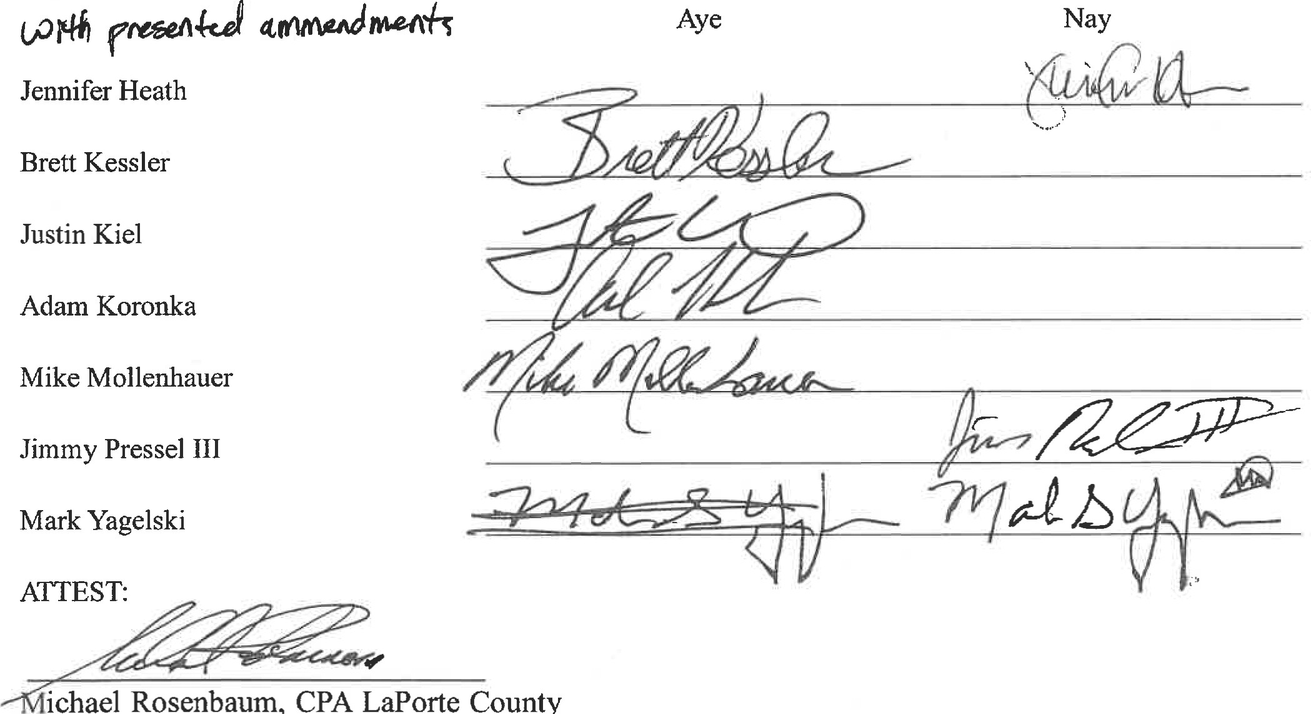
ichael
Rosenbaum,
LaPorte
County
Auditor
ORDINANCE #2026-09
ORDINANACE MODIFYING LOCAL INCOME TAX RATES
LAPORTE COUNTY
ADDENDUM
In association with the adoption of this tax, the County Council will affect the following:
- A capital projects plan describing all needed or anticipated building improvements and vehicle replacements over $50,000 expected to occur in the next three years shall be produced, adopted, maintained, and published on the county website.
- A full report of year-to-date expenditures relative to budgeted amounts shall be prepared each month and shared with all Council Members and posted on the county website in a digital, standardized plain text or comma separated values format.
- The packets for each meeting, excluding only any information that would be considered non-releasable under the Indiana Access to Public Records Act, shall be posted on the county website no less than three calendar days before each meeting.
This local income tax increase will expire on December 31, 2027, unless the
County Council certifies by resolution with a majority vote no later than October 1, 2027, that it has fulfilled the requirements of this ordinance in its entirety.

