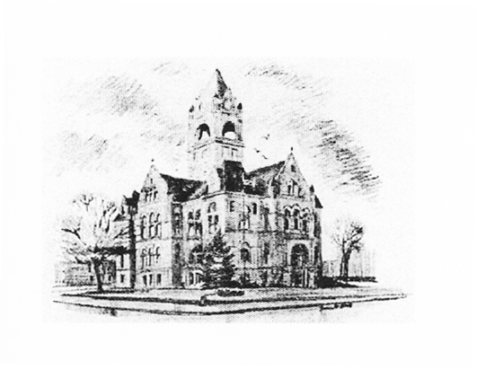
Katie Bowen, LaPorte County Election Board President
Julie Sinclair, LaPorte County Election Board Member
Heather Stevens, Circuit Court Clerk/ County Election Board Secretary
LaPorte County Election Board
Taylor Van Sickle, Election Deputy ELECTION DIVISION
(219) 326-6808, Ext. 2471 LAPORTE COUNTY COURTHOUSE
813 LINCOLNWAY, SUITE 105
LAPORTE, IN 46350-3492

The La Porte County Election Board will hold a public meeting at 1:00pm, on Monday, March 30, 2026 in Meeting Room 3 of the La Porte County Complex.
(809 State St. La Porte, IN 46350)

Notice issued on March 26, 2026 at 10:00am by:
Taylor VanSickle
LaPorte County Election Deputy

