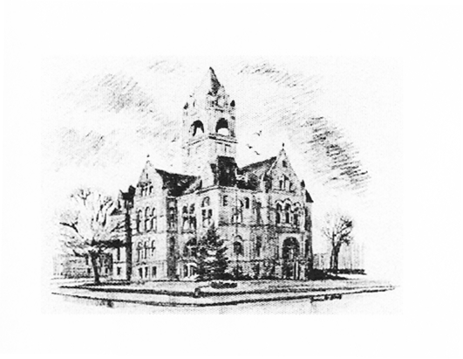
Katie Bowen, LaPorte County Election Board President
John Lake, LaPorte County Election Board Member
Heather Stevens, Circuit Court Clerk/ County Election Board Secretary
LaPorte County Election Board
Taylor Van Sickle, Election Deputy ELECTION DIVISION
(219) 326-6808, Ext. 2471 LAPORTE COUNTY COURTHOUSE
813 LINCOLNWAY, SUITE 105
LAPORTE, IN 46350-3492

The La Porte County Election Board will hold a public meeting at 3:00pm, on Friday, June 13, 2025 in Meeting Room 3 of the La Porte County Complex.
(809 State St. La Porte, IN 46350)

Notice issued on June 5, 2025 at 2:00pm by:
Heather Stevens
Circuit Court Clerk/Election Board Secretary

