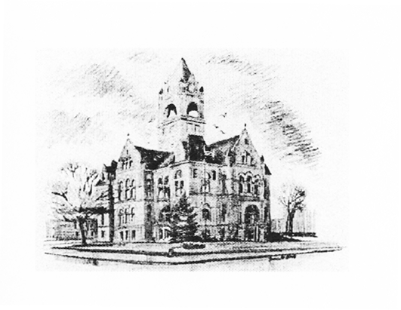
Brody Shoffner, LaPorte County Election Board President
Teresa Massa, LaPorte County Election Board Member
Heather Stevens, Circuit Court Clerk/ County Election Board Secretary
LaPorte County Election Board
Taylor Van Sickle, Election Deputy ELECTION DIVISION
(219) 326-6808, Ext. 2471 LAPORTE COUNTY COURTHOUSE
813 LINCOLNWAY, SUITE 105
LAPORTE, IN 46350-3492

The La Porte County Election Board will hold a public meeting at 1:00pm on Monday, 24th, 2024 in Meeting Room 3 of the La Porte County Complex.
(809 State St. La Porte, IN 46350)

Notice issued on June 18, 2024 by:
Heather Stevens
Circuit Court Clerk/Election Board Secretary

Agenda

Monday, June 24, 2024 at 1:00 p.m. County Complex Room 3

- Call to Order
- Pledge of Allegiance
- Roll Call
- Approval of Agenda
- Approval of Minutes
  - April 12, 2024
  - May 02, 2024
  - May 17, 2024
- Public Comment
- Old Business
  - Democratic Civic Club
- Proxy introduction for President Brody Shoffner
- New Business
  - Rodney McCormick Campaign Finance Hearing
  - Committee to Elect Mike Rosenbaum Campaign
10. Board Member Comments
11. Adjourn

