LaPorte County Call to Action – Broadband
The La Porte County Office of Community and Economic Development asks residents and businesses to submit their addresses to the Indiana Connectivity portal following the below process.
Please find below information regarding the program, timing, and process. Any additional questions can be directed to the Office of Economic Development.

Round 9 Awards:
The Indiana Connectivity Program announced the ninth round of awards on April 4, 2024. The ninth round of the program awarded $657,886 to expand broadband to 152 addresses across 21 counties. Of these addresses, 146 are homes and six are businesses. Internet providers carrying out the projects matched $,016,458 for a total investment of $1,674,344.
To find the number of addresses funded by each provider, click here. To find the number of addresses funded in each county, click here.
For the map of the funded locations for ICP Round 9, click here.
Provider | Addresses | Grant Amount
Airwave Networks, LLC | 13 | $62,400
Auburn Essential Services | 1 | $4,800
Berry Communications | 1 | $4,800
Central Indiana Communications | 12 | $54,994
Joink Inc. | 24 | $92,594
Mulberry Telecommunications | 24 | $114,150
On-Ramp Indiana, Inc. | 5 | $24,000
PSC Fiber | 51 | $199,348
SEI Communications | 21 | $100,800
Total Awarded | 152 | $657,886

Overview: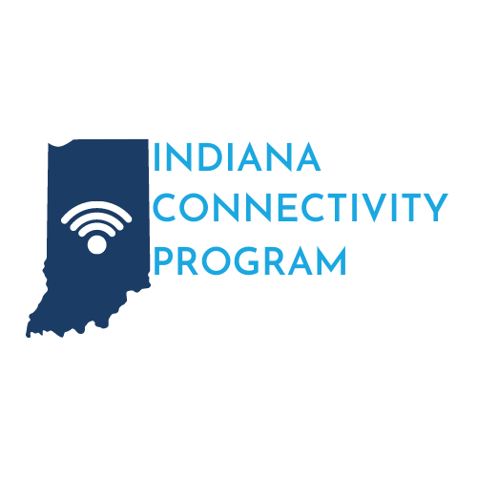
The Indiana Connectivity Program aims to connect residents and businesses that lack access to broadband internet service with service providers and assist in the expense of extending broadband to those locations.

Process:
Owners of residential and business locations unserved or underserved (access to actual speeds less than 100 Mbps download and 20 Mbps upload) can apply for consideration by entering their information into the Next Level Connections portal to initiate their interest in receiving broadband internet service.
Internet Service Providers will have the opportunity to review these locations and submit bids to the state on the cost of providing service to these locations. OCRA will evaluate these bids and make awards to the providers whose bid presents the lowest cost per Mbps to the state for extension of the service.
Status | Description
In-Progress | Application incomplete. Please submit your application to OCRA
Submitted for OCRA Review | Your application is under initial review by OCRA staff
Not Approved or Previously Awarded Funding | Your application could not advance, please log in to the portal and open My Applications to see an explanation
Staged for Challenge, Released for Challenge, Challenge Evaluation | OCRA is reviewing existing services offered for your address
Valid Challenge | A broadband provider can offer existing services and will contact you
Open to Bundle, Staged for Bid, Released for Bid, Bid Evaluation | Your application is under consideration by broadband providers
No Bid or No Valid Bid | No provider submitted a bid or was awarded. Your application will be included in the next round.
Awarded | A broadband provider has been selected to provide services for your address and will contact you
*Inputting location information into the Next Level Connections portal does not guarantee extension of service.
*If a resident or business cannot access the online portal, the Indiana Broadband Connect Center can assist in this process. Please call 833-639-8522.

Eligibility:
Locations that currently lack broadband service or have actual broadband speeds of less than 100/20 Mbps are eligible. The location can be residential or business.

Funding:
The portfolio of Next Level Connections Broadband Programs has been allocated $270 million in total. This would include the Indiana Connectivity Program.
Limits per line extension are set by Indiana Code. These limits are:
*A per-line extension amount that cannot exceed $25,000.
*A per passing amount that cannot exceed $4,800.

Timeline:
The Indiana Connectivity Program and Next Level Connections online portal is accepting applications.
The bidding and challenge processes must take place before awards can be made. Once made, projects must be completed within six to nine months of the contract date.
- At least every three months, OCRA will publish to registered providers the addresses requesting service
- Service providers will have 10 days to notify OCRA of service availability at those locations
- Service Providers have 60 days to submit bids on locations they would like to extend service to
- OCRA will evaluate all bids within 30 days and select the provider whose bid presents the lowest cost per Mbps to the state.

Round 10 Timeline
Addresses Posted for Challenge | March 11, 2024
Challenges Due | March 22, 2024
Addresses Posted for Bid | April 12, 2024
Bids Due | June 3, 2024
Selections Announced | July 2024
All dates are subject to change. The Indiana Connectivity Program address enrollment is ongoing.

How to submit your information:
Indiana residents and business owners can submit their address and information through the online portal, by phone at 833-639-8522 or by mail to the following address:
Attn: Indiana Broadband Connect Center
The Office of Community and Rural Affairs
1 N. Capitol Ave.
Suite 600
Indianapolis, IN 46204

Resources:
- Next Level Connections Portal
- One page overview
- Indiana Connectivity Program Challenge Webinar
- Connectivity - Business Video
- Connectivity - Health Clinic 1G Video
- Connectivity - Household Video
- Connectivity - School 1G Video
- Indiana Connectivity Program Scope of Work Template
- Indiana Connectivity Program Budget Table Template
- Indiana Connectivity Program Speed Test Template
- Indiana Connectivity Program Scoring Criteria

