LA PORTE COUNTY HEALTH DEPARTMENT
Sandra Deausy M.D., Health Officer Tony Mancuso, Administrator
Government Complex
809 State Street, Suite 401 A
La Porte, Indiana 46350

219-325-5563
219-326-6808 Ext. 2200
219-325-8628 Fax

Michigan City Office
302 West 8th Street, Suite 4
Michigan City, Indiana 46360

219-809-0515
219-874-5611 Ext. 7780
219-873-3018 Fax

lphealth@laportecounty.org

AMENDED HEALTH ORDER

LaPorte County Health Officer’s Order as requested by Mayors, County Elected Officials and local legislative delegation to address late Fall, 2020 surge in Covid-19 cases in LaPorte County, Indiana

WHEREAS, across the State of Indiana and LaPorte County, cases, deaths and hospitalizations from Covid-19 have trended downwards in the past several weeks,

WHEREAS, LaPorte County now has a positivity rates of 10.6 percent, placing this county among the Orange category of counties, and

WHEREAS, pursuant to the laws of the State of Indiana, I have the authority under I.C. 16-20-1-24 to “forbid public gatherings when considered necessary to prevent and stop epidemics,” and I.C. 16-20-1-25 also allows me to “abate” any condition that may “transmit, generate or promote disease” and,

WHEREAS, I have consulted with a range of local elected officials including our county commissioners, county council president, the Mayors of both the City of LaPorte and City of Michigan City as well as our local state legislative delegation,

Whereas, the Governor has instituted some new restrictions that are incorporated herein and he has given discretion to local health departments to take other such actions as are necessary to address this pandemic,

NOW THEREFORE PURSUANT TO THE AUTHORITY VESTED IN ME BY THE LAWS OF THE STATE OF INDIANA, I HEREBY DECREE AND ORDER THE FOLLOWING

- Consistent with the Governor’s executive order 21-02 on restrictions for Orange and Red counties – social gatherings and events shall not exceed 25% of a facilities capacity.

- Social gatherings and events of more than 25 people (including staff) will need approval from the LaPorte County Health Department. The host of the event will need to submit a safety plan to the health department at least five (5) days in advance of the event/gathering.

- Governor’s mask mandate remains in full force and effect with both employees and patrons at any business required to wear a mask that fully covers both the nose and mouth.

- Indoor and outdoor capacity for bars, restaurants and entertainment venues to be governed strictly by CDC social distancing guidelines.

- Gyms and fitness studios, including locker rooms are subject to strict adherence to social distancing requirements.

- Libraries, funeral homes, swimming pools are also subject to strict adherence to social distancing requirements

- Employees, patrons or members of the general public are encouraged to contact the LaPorte County Health Department Covid-19 hotline at 219/362-2525 with reports of non-compliance with this Order.

ALL OF WHICH IS ORDERED THIS 4th DAY OF February, 2021 and will continue in full force and effect until further notice.

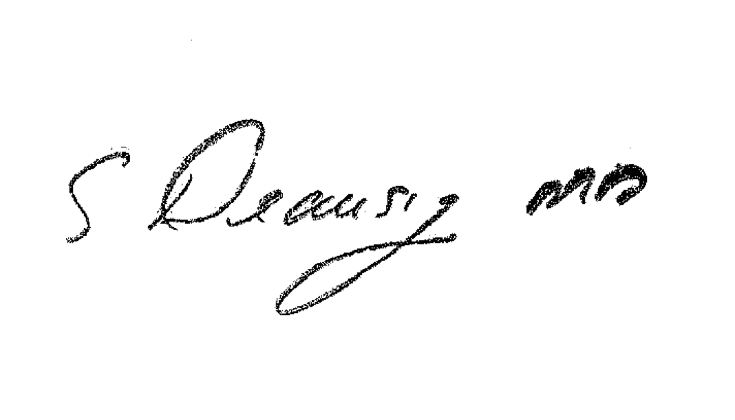
Sandra Deausy, M.D.
LaPorte County Health Officer

