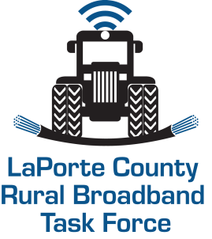

The La Porte County Broadband Task Force has been in contact with nearly all of the Internet Service Providers in and or serving the Greater La Porte County Geographic Area.

The following list of Internet Service Providers are available to field your questions and concerns about your connectivity challenges that may arise during this time increased remote work from home as well as e-learning connectivity challenges.

AT&T- (219) 873-1144
https://www.att.com/support/contact-us

Comcast- (800) 934-6489
https://my.xfinity.com/
ACME Communications - (219) 809-0066
https://www.acmetc.com/

Frontier- (800) 921-8101
https://business.frontier.com/
Surf Air / Maple net – (219) 326-5252
https://www.surfbroadband.com/
Net Nitco - (219) 996-2981
https://www.nitco.com/
MEDIA Com - (855) 633-4226
https://www.mediacomcable.com/

Sincerely,
Tony Rodriguez, EDFP., Dir. Sheila Matias, President
Community & Economic Development – Co Chair La Porte County
Board of Commissioners- Co-Chair

